**In written work you could check**:

* Full stops and capital letters.
* New paragraphs when there is a change of topic or idea.
* Homophones – words that sound the same but have different spellings and have different meanings. For example there/they’re/their, where/wear (and were), been/being.
* Would have/could have rather than would of/could of.
* Apostrophes.
* That they are using complex sentences.
* Formal language is being used throughout.

**Useful websites to help with literacy:**

* <http://www.bbc.co.uk/skillswise/english>
* <http://www.bbc.co.uk/education>
* <http://www.bbc.co.uk/bitesize>

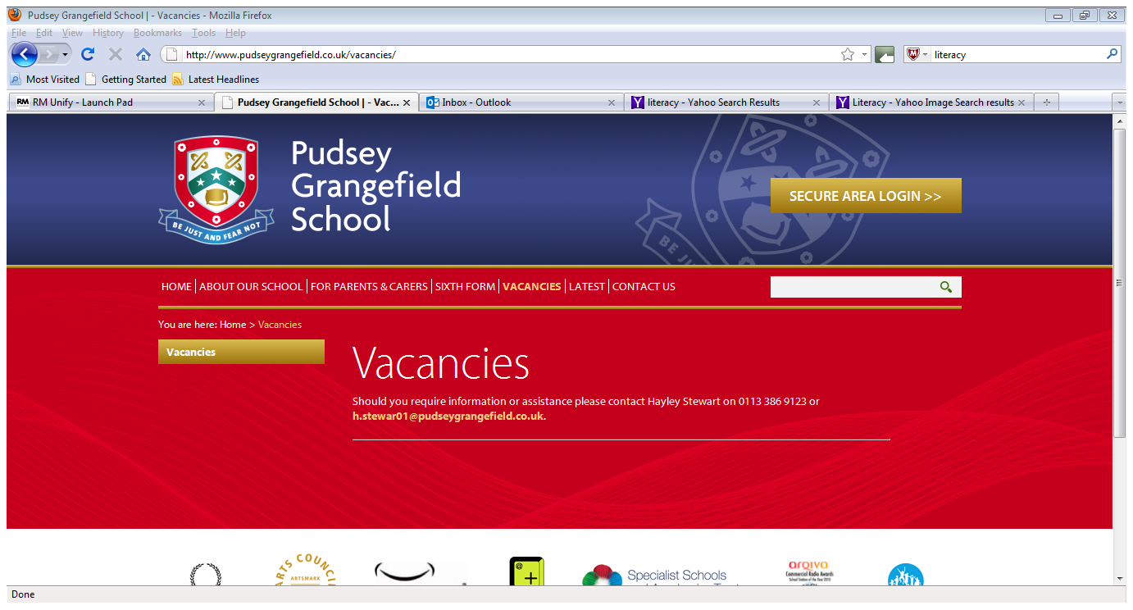

**Literacy Information Evening**

**Thursday 19th October 2017**



**Overview of the evening:**

* To share the Key Stage Three English curriculum.
* To give advice as to the types of help parents can give their children with regards to their literacy skills.
* To provide tips and guidance about certain aspects of literacy.
* To answer queries you may have regarding literacy.

**Topics studied at Key Stage 3 English**

**Year 7**

* Animal Farm
* Love and conflict
* Ghostly encounters
* A Midsummer Night’s Dream

**Year 8**

* Our World
* Blood Brothers
* Traces of evidence
* Stop the press!
* Myths and Legends

**By the end of Key Stage 3 English we expect students to:**

* Read skilfully, drawing on a number of a reading strategies, such as inferring, deciphering meaning, responding to challenging texts and analysing content.
* Write effectively, using accurate and effective vocabulary, spelling, punctuation and grammar, adapting their writing to different forms, audiences and purposes, with creative and imaginative content.
* Communicate skilfully, using a range of different verbal and non verbal strategies to express themselves in a range of situations with a range of audiences.

**How can parents/carers help?**

* Read through homework to check for basic errors.
* Discuss current news topics with your child and encourage them to use more formal language.
* Sign students planners with the reading they have completed for the week.