**ALevel Level Art - Project title: ____________________________________________**

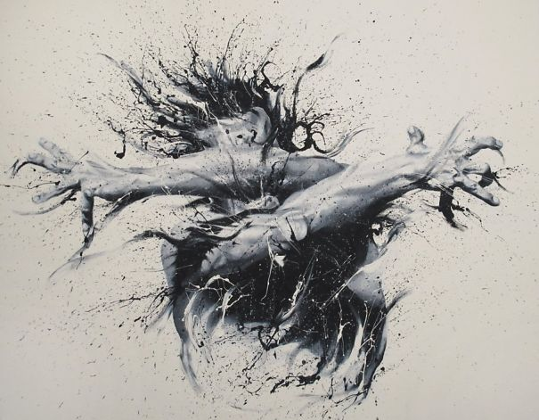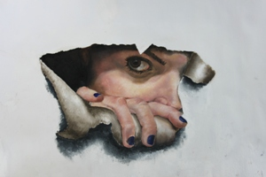 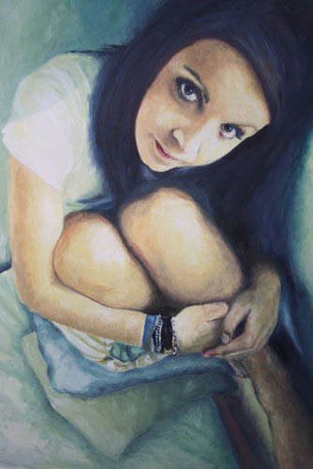

**[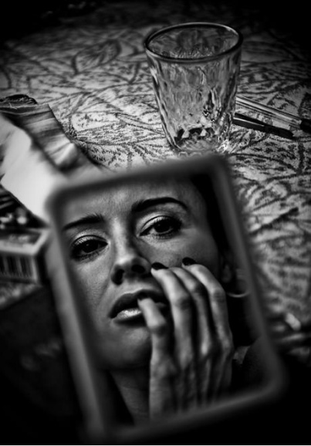](http://media-cache-ak0.pinimg.com/originals/8b/de/a0/8bdea02cbb1de43b8b4d6906900d0649.jpg)[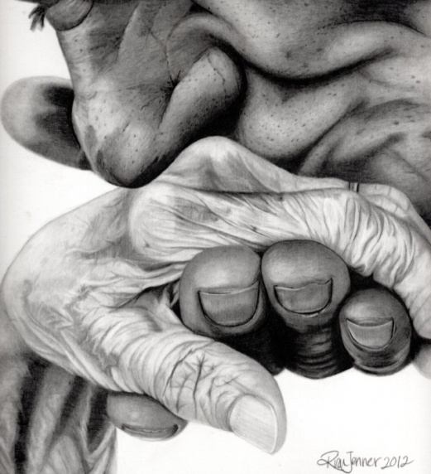](http://www.facebook.com/risajenner.art)**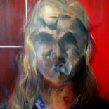

**[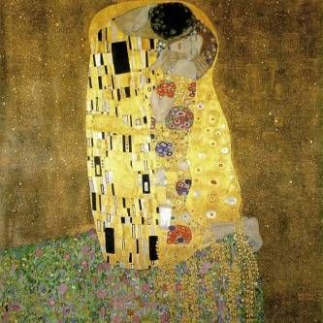](http://www.lifesensuals.com/life-sensuals-blogs/entry/invisible-love-the-kiss.html)[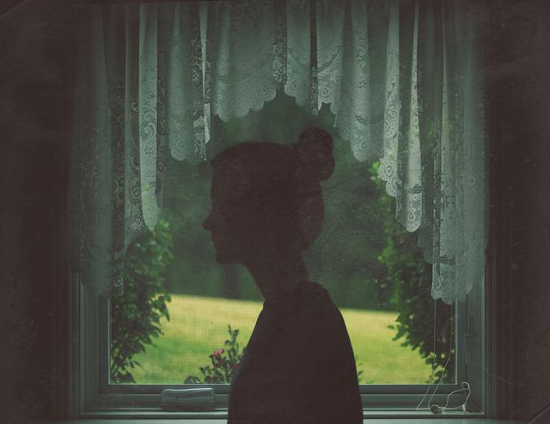](http://121clicks.com/inspirations/hidden-faces-in-fine-art-portrait-photography)** **[](http://images.search.yahoo.com/images/view;_ylt=A0PDoQ50QL1PJxUAPsOJzbkF;_ylu=X3oDMTBlMTQ4cGxyBHNlYwNzcgRzbGsDaW1n?back=http://images.search.yahoo.com/search/images?p%3Dpain%26phrase%3D1%26fr%3Dyfp-t-701-1%26fr2%3Dpiv-web%26tab%3Dorganic%26ri%3D197&w=900&h=900&imgurl=fc04.deviantart.net/fs71/i/2010/209/0/5/Black_and_white___Pain_by_misslarisacroft.jpg&rurl=http://misslarisacroft.deviantart.com/art/Black-and-white-Pain-173116163&size=61.5+KB&name=Black+and+white+-+Pain+by+*misslarisacroft+on+deviantART&p=pain&oid=81f2ac46f5eea16ac264446d61d55a0b&fr2=piv-web&fr=yfp-t-701-1&tt=Black%2Band%2Bwhite%2B-%2BPain%2Bby%2B%2Amisslarisacroft%2Bon%2BdeviantART&b=181&ni=200&no=197&ts=&tab=organic&sigr=128nqu869&sigb=13a54c0jk&sigi=12le6jb60&.crumb=0ntNq60Y8A8)**