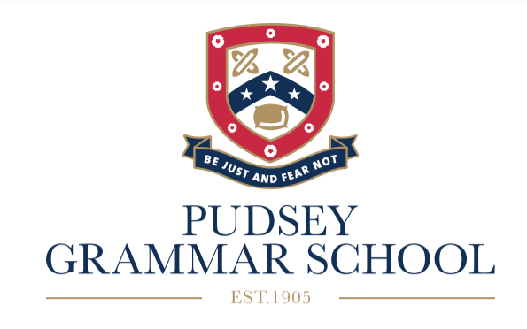

Key Stage 4
Guided Choices 2024
Name ……………………………………………….
Form ……………………………………………….

Welcome to the guided choices process in Year 9. This is an exciting time for you, as you now have the opportunity to choose some of the courses you would like to take in Years 10 and 11.

This guidance will help you and your parents/carers understand the process and will give you some suggestions about how to choose the courses. There is also a lot of support at hand and you can discuss your choices with your subject teachers, form tutor, Director of Studies and parents/carers.

All students will be guided with their choices. We want the courses chosen by students to provide them with the best possible chance of success, as well as ensuring that their curriculum is broad, balanced and enjoyable.

Core Subjects
All students will take the following subjects in Year 10 and 11:
English Language and Literature GCSE,
Mathematics GCSE,
Combined Science (2 x GCSE).
Students will also take the non-examined courses of PE, Core RE and
PSHE (Personal, Social and Health Education).

Important Dates in the Guided Choices Process
Guided Choices Assembly- Monday 18th March
Guided Choices pamphlet given to students – Tuesday 19th March
Subject Fair -Tuesday 19th March 5-7pm (presentations at 5pm and 6pm)
Guided Choice forms open - Friday 22nd March
Deadline for completed forms – Thursday 28th March
Meetings with some students to discuss choices – After Easter holidays
Letters to go to parents/carers with course selection -End of May

Guided Choices
In addition to the Core Subjects, you must choose History or Geography GCSE. We will be encouraging as many students as possible to pick a Modern Foreign Language which are French, Spanish or Mandarin. Students must then pick 3 more courses. This gives 4 courses in total. The courses must fit into the Guided Choices Blocks, with one course from each of the 4 blocks. You must also pick 2 reserve courses from any of the blocks just in case we are unable to offer your preferred courses.

How to choose
You should select courses that;
- you are interested in,
- you have the relevant skills in, or are keen to develop those skills,
- you can be successful in,
- may be relevant to any future career aspirations.

Combinations of subjects
You cannot choose the following subjects together;
- Enterprise (BTEC) and Business GCSE,
- ICT (BTEC) and Computing GCSE,
- Performing Arts (BTEC) and Drama GCSE,
- Hospitality & Catering(BTEC) and Food Technology GCSE,
- Construction (BTEC) and Product Design GCSE.

Guided Choices Blocks
The courses must fit into the Guided Choices Blocks below, with one course from each of the 4 blocks. You must also pick 2 reserve courses from any of the blocks just in case we are unable to offer your 4 preferred courses.
Block 1 | Block 2 | Block 3 | Block 4
Art  GCSE | Art  GCSE | Business Studies  GCSE | Child Development  BTEC*
Enterprise  BTEC* | Computing  GCSE | ICT  BTEC* | Business Studies  BTEC*
Food Technology  GCSE | Construction  BTEC* | Drama  GCSE | French  GCSE
Geography  GCSE | Health & Social Care  BTEC* | Geography  GCSE | Geography  GCSE
History  (2 groups)  GCSE | History  GCSE | Hospitality & Catering  BTEC* | History  GCSE
Performing Arts  BTEC* | Mandarin  GCSE | History  (2 groups)  GCSE | Media  Cambridge National*
RE  GCSE | Media  Cambridge National* | Photography  GCSE | Photography  GCSE
Spanish  GCSE | Music  BTEC* | Sport Science  Cambridge National* | Product Design  GCSE
 | PE  GCSE |  | PE  GCSE
*These are vocational courses.

Types of courses
You should also consider the type of course as well;
- Many GCSEs (e.g. Maths, History) are 100% examined at the end of Year 11,
- Practical GCSEs (e.g. Art, Drama, Product Design) and vocational courses (e.g. Sports Studies, Media) have a controlled assessment/ coursework element (60%) as well as an end of course examination (40%).
- Vocational courses have internally assessed units which are set by the exam boards. You must have excellent attendance to prepare and complete these units in the given time.

What will happen if a course is oversubscribed or undersubscribed?
There is only one class for each of the courses in the blocks. The maximum size of a class depends on the type of course. For example, History GCSE classes can have a maximum of 32 students, whereas practical subjects like Food Technology GCSE are smaller with a maximum number of 25 students. If a course is oversubscribed we will use students’ KS3 assessments and ATLs to help decide if they are suitable to take the course. A course may not run if the numbers are not viable.

How to find out more about the different courses
At the Subject Fair each of the subject areas will be represented and will have information about the courses they run. You will be able to find out more about the different courses by talking to the teachers on that evening. There is also a great deal of information on the school website about each course including the content of the course, how it is assessed and examples of students’ work;
www.pudseygrammar.co.uk
then click on the tabs; Year 6-11/Year 9/Guided Choices 2024
Or use the QR code below;

