Respect Resilience Integrity Compassion Ambition

English and Literacy information

Welcome

This first year at secondary school is a big step up, with lots of interesting subjects to get used to, a different building to explore and new teachers and friends to meet. Our extensive transition programme gives our new students lots of chances to meet us before they start, but we understand that settling in doesn’t always happen overnight and we are here to support them every step of the way.
Lessons at secondary school are a very different experience to those at primary level. Our teachers are subject specialists with very high standards and want to support our students to realise their potential; working hard, showing resilience and having a positive attitude is key.
Year 7s also have to learn to take more responsibility for themselves with their homework and behaviour than they might be used to. Getting into good habits, and being accountable for their actions, is something our students will be working hard to develop, and we very much appreciate support from parents with this at home.
There are so many exciting opportunities to take advantage of in Year 7, from sports teams, lunchtime clubs and an extensive range of enrichment activities to our brilliant Bush Craft residential trip to Castle Howard. We certainly work hard, but we make sure we all enjoy school life too. We expect our Year 7s to throw themselves into their first year at the Pudsey Grangefield School and make every day count.

Mr Matthews
Director of Studies Y7&8

English and Literacy Information

Topics studied at Key Stage 3 English

Year 7 | Year 8
Animal Farm | Our World
Love and Conflict | Blood Brothers
Ghostly Encounters | Traces of Evidence
A Midsummer Night’s Dream | Myths and Legends

By the end of Key Stage 3 English we expect students to:
- Read skilfully, drawing on a number of a reading strategies, such as inferring, deciphering meaning, responding to challenging texts and analysing content.
- Write effectively, using accurate and effective vocabulary, spelling, punctuation and grammar, adapting their writing to different forms, audiences and purposes, with creative and imaginative content.
- Communicate skilfully, using a range of different verbal and non verbal strategies to express themselves in a range of situations with a range of audiences.

How can parents/carers help?
- Read through homework to check for basic errors.
- Discuss current news topics with your child and encourage them to use more formal language.
- Sign students planners with the reading they have completed for the week.

Useful websites to help with literacy:
- http://www.bbc.co.uk/skillswise/english
- http://www.bbc.co.uk/education
- http://www.bbc.co.uk/bitesize

KS3 Numeracy

Year 7 Overview
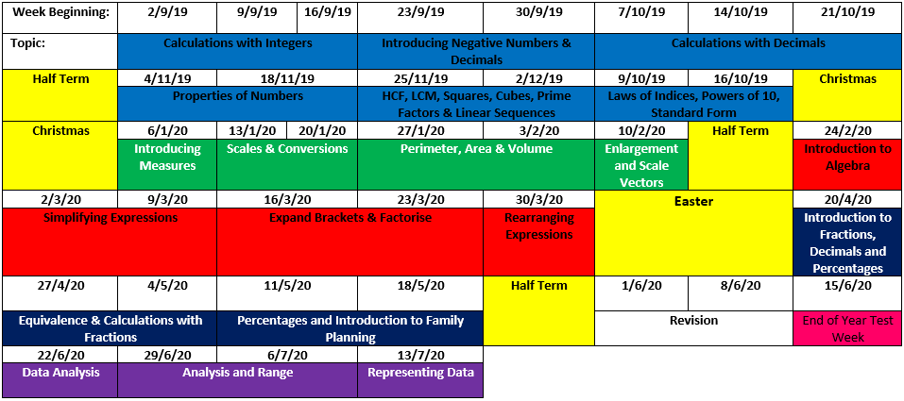
Key Points:
- Practise Mental Maths skills
The more often students use mental maths skills the better they become at them and the faster they are able to recall mathematical facts. It is no secret that the students with better mental mathematical skills are able to access and achieve the higher grades at GCSE and beyond. We will be checking mental maths skills in class on a weekly basis. They best way you can help is to practise things like Multiplication Tables with your child at home. This could be by chanting, through games, quizzes, whatever you like. The more regular the practice the better.

- Use the internet!
We appreciate that it is not always possible to help your child at home with their maths work. There are thousands of very good maths websites that can be very useful for home learning. Even if you don’t know any, you can just search for any maths topic, term or question on Google or even YouTube and you will find a relevant resource.
Key Websites:
- Hegarty Maths – used for their homework (videos and online quizzes) - www.hegartymaths.com
- Corbett Maths - more instructional videos and printable worksheets - www.corbettmaths.com
Modern Foreign Languages

Curriculum:
- Students study French until Easter and Spanish from Easter until the end of the summer term.
- Some students will also be following a course in Mandarin Chinese

Homework:
- Students will receive up to 45 minutes of homework per week. This may include worksheet based tasks as well as vocabulary learning. Teachers will expect to see evidence of look, cover, write and check with red pen for any vocabulary learning task set.

Dictionary use - hints for home and school:
- Finding the right meaning
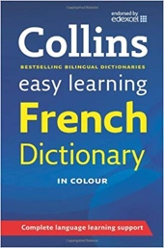
The most common mistake that inexperienced dictionary users make is to take the first answer they find. Modern bilingual dictionaries go to great lengths to point the user towards the correct meaning, by signposting meanings in the user's own language and by giving examples of use. Encourage students to look at the signposts and examples and get into the habit of using them.

Some high frequency phrases to get to grips with to support your child in their first term of French at Pudsey Grangefield:

Je m'appelle - I’m called | J’adore - I love
C'est - It’s | Et - And
Aujourd'hui - Today | Est - Is
Selon moi - According to me | Je déteste - I hate
Je pense que - I think that | J'ai - I have
Å mon avis - In my opinion | Ennuyeux - Boring
Parce que/car - Because | Très - Very
Je n’aime pas - I don’t like | Je suis - I am
J’aime - I like | Je vais - I go/I’m going
J’habite - I live

E-Safety Information for Parents/Guardians

Online Reputation
The internet provides permanent records of everything you post on Social Media, if not controlled carefully, it may be accessible to:
- Future employers
- Universities
- Friends
- Young people should think about:
- What they share
- Where they share it
- Who they share it with

Cyber Security Tips:
- Choose strong passwords.
- Be mindful when installing programs or downloading attachments.
- Use Firewall/Anti-Virus programs.
- Don't fall prey to phishing scams.
- Limit the information you share on social media.

Internet Filters
All UK Internet Providers are required to offer filtering services to help protect children whilst using the Internet. A Family filter should be automatically enabled on Home Broadband connections although most Mobile Phone connections require the user to opt-in to the Family filter.
Please check with your home broadband and mobile provider that Family filters are enabled on all connections your children have access to.

Smartphone/Tablet Parental Controls
Both Apple iOS and Google Android operating systems offer Parental controls to be enabled on smartphone and tablet devices. Apple have introduced the Screentime tool which allows for time limits and restrictions to be placed on popular apps. Android offer the Family Link tool which has the same features.

Useful Links:
NSPCC - https://www.nspcc.org.uk/preventing-abuse/keeping-children-safe/online-safety/
Think U Know - https://www.thinkuknow.co.uk/parents/
Internet Matters - https://www.internetmatters.org/issues/
Safer Internet - https://www.saferinternet.org.uk/

Popular Questions and Answers:

- Where is lost property?
All lost property is sent to the library. Students need to visit at break/lunch time. It is their responsibility.

- Who do I contact?
- When do I receive information about feedback on student’s attitude to learning?
- Progress Updates 1: November, 2: February & 3: July
- The focus in Y7 is all about Attitude to Learning: Behaviour, Homework and Classwork

- How else can I help my child?
- Routines: encourage your child to pack their bags according to their timetable.
- Check Class Charts regularly
- Telephone school before 8:15am if your child is going to be absent
- Make sure students have their name written in all their clothes and PE Kit

- What do I do if my child is going to be absent?
- We would ask that you telephone school before 8:20am
Attendance Office Number – 0113 386 9122

Key Contacts

Form Tutor Name:
Form Tutor Subject:
Form Tutor E-mail:

Head of Year 7 | Mrs. G. Mullan
E-mail | g.mullan01@pudseygrangefield.co.uk

Director of Studies Y7&8 | Mr. D. Matthews
E-mail | d.matthe01@pudseygrangefield.co.uk

Key Dates

Year 7 Parents Evening
Thursday 7th November 4:30-7:00pm
An opportunity for parents/carers to meet class teachers

Bush Craft Residential
Wednesday 24th – 26th June 2019
An opportunity for students to develop a wide range of skills outside the classroom

